NEW PATIENT QUESTIONNAIRE

NAME:_________________________ DATE:___________

DENTIST’S NAME: _____________________________________

At Benson Orthodontics, we want to see how our patients hear about us and what motivated you to call our office. Thank you in advance for your time! Check all that apply.

We know from our initial conversation that you heard about us from__________________.
We would appreciate your help by indicating any other ways you saw or heard about our office.

- My dentist
- My family member was treated/is being treated by Dr. Benson, friend, neighbor, co-worker or one of our patients recommended you (Name:_________________________)
- Heard about you through school, sports, church or community activity(Please circle)
- Damon website referred me
- Your staff referred me to the office (Name:_______________________________________)
- Received your postcard
- Internet
- Saw your sign while driving by
- Invisalign referred me
- Other (______________________________________________________________________)

What is your main concern?
Overjet (buck teeth) Spaced teeth Crooked/Crowded teeth

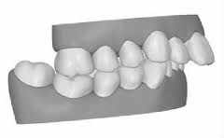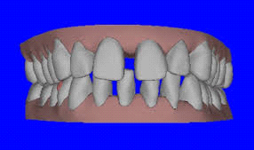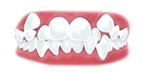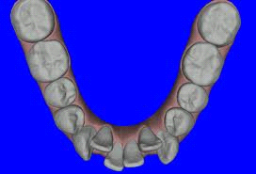

What treatment option are you most interested in?
Metal Braces Clear Braces Invisalign

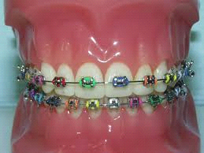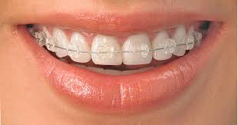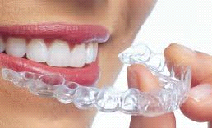

What payment options would be best for you?
____Payment in full with special discount ____ Care Credit
____In-house financing – no interest ____ Flexible Spending Account

Do you have insurance or flex plan benefits you would like for us to confirm?
___ Yes
___ No
If so, please provide the following: Subscriber’s Name___________________
DOB ____________________
SSN ____________________
Card ID # _________________
Employer ________________
Insurance ________________
Insurance Phone # ________________

Is there anyone else who is going to be involved in the decision to start treatment?
___ Yes Involved party _____________________________________
___ No

Have you had another orthodontic consultation?
___ Yes Dentist/orthodontist _________________________________
___ No
Are you allergic to latex or any medications?
------Yes ____________________________________________________
___No
Are there any health concerns we should be aware of?
___ Yes ____________________________________________________
___ No

On a scale of 1 to 5, with 5 being ready to start, how ready to start are you?
1 2 3 4 5

Please sign for permission to:
___ Permission to take x-rays, photos
___ Post name and photo in contests/social media

Date: _____________
Name: _________________________________
Signature: ___________________________________

We appreciate your thoughts!!! Dr. Benson and TEAM

